**Experiment 2:-**

Design an LED Chaser

**Circuit Diagram:-**

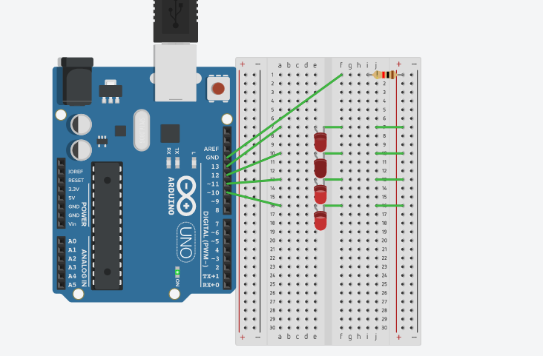

**Theory:-**

**Concept Used:-**

The concepts used while doing this experiment are:-

* The arduino board can supply a power of 5V as digital output signals through the 14 pins.
* The GND pin of the arduino board acts as ground.
* In the bread board present in the above circuit diagram the two rows present at the top and bottom each, are connected with each other in series and the columns present in between are connected in a set of 5 each. The connection pattern is shown below: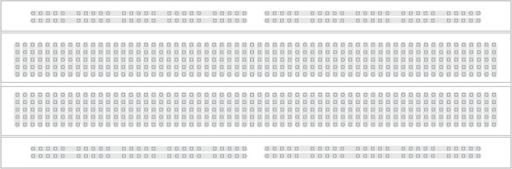
* Kirchoff’s current law:- It states that the total current entering a junction is equal to the current flowing out of the junction.
* Ohm’s Law:-Ohm’s law states that the current passing through a conductor is directly proportional to the voltage across the two points provided that the physical conditions remains constant.

V=IR

**Learning and Observation:-**

**Learnings:-**

* I have learned to make a parallel circuit connection using an Arduino board and a breadboard.
* I have also learned how to make different glowing patterns of LED.

**Observations:-**

* I observed that the first two LEDs glows and then the first LED goes off and the third one glows and the pattern continues similarly.

**Problems and Troubleshooting:-**

* The LEDs may not be working properly.
* The wire of the Arduino board may not be in proper working condition due to which the code is not working.

**Precautions:-**

The precautions that we need to remember while doing this experiment are:-

* The wires should be inserted properly.
* The two pins of the LED should be connected at their appropriate position that is the positive point should be connected with the positive pin and the negative point should be connected with the negative pin.

**Learning Outcomes:-**

* I have gained the skill of making different types of patterns of light using LEDs.
* I have learned how to work practically with an Arduino board and make different patterns.